Article

The Study of Locomotion Method for Panoramic Videos:

System Usability and a Sense of Presence

Andrius Paulauskas1, Tomas Blažauskas1*, Aurelija Skučaitė1,Cenker Canbulut 1,Mindaugas Vasiljevas1, Dominykas Barisas1, Lukas Paulauskas1,Mikas Binkis1 and Tomas Valatkevičius1

|  |
| --- |
| **Citation:** To be added by editorial staff during production.  Academic Editor: Firstname Lastname  Received: date  Revised: date  Accepted: date  Published: date    **Copyright:** © 2022 by the authors. Submitted for possible open access publication under the terms and conditions of the Creative Commons Attribution (CC BY) license (https://creativecommons.org/licenses/by/4.0/). |

1 Kaunas University of Technology

**\*** Correspondence: tomas.blazauskas@ktu.lt;

**Abstract:** In this paper, we investigate the locomotion method dedicated to Virtual Reality (VR) solutions that allow movement within a scene using pre-rendered panoramic videos. The aim of the study is to evaluate the usability of the proposed locomotion method. To compare the proposed approach with regular implementations that use 3D scenes, the sense of presence is investigated, as well. Moreover, the study aims to answer the following questions through experiments: which is the preferable method to make a transition from one panoramic video to another; which navigational object, static lines or dynamic arrows, is preferable and more intuitive to use and which transition method has the least negative physiological consequences and is more pleasant to use. The study shows - while the usability and a sense of presence characteristics of the investigated locomotion are good enough, the regular implementation using 3D models provides better usability and a sense of presence.

**Keywords:** VR, usability, sense of presence, panoramic videos, three-dimensional content.

1. Introduction

David Burden identified two VR content types- three-dimensional modelled and two-dimensional panoramic content (Fig. 1). He linked the content type to the existing headsets to identify fields of applications.

A screenshot of a cell phone

Description generated with very high confidence

**Figure 1.** Landscape for VR [21].

David Burden suggested that it is easy to create high-quality static panoramic content, and it is easy to render it on cheaper devices, but such content lacks interactivity. On the other hand, a three-dimensional, modelled scene allows for creating much better interactivity and immersion, but requires expensive headsets and a computer, because rendering is computationally expensive. Also, the creation of the three-dimensional scene requires more effort. One of the main differences between panoramic and modelled content is that VR devices allow natural movement within a modelled world. This feature has a significant impact on immersion. Therefore our goal is to improve the immersion of two-dimensional content by applying different locomotion methods designed for that content. The study is intended to evaluate the usability and the sense of the presence of a locomotion method that uses panoramic video content for rendering VR.

The effects caused by a sense of presence have been investigated for some time already. However, the emergence of new VR technologies increased the availability of VR devices and their prevalence. The latest technical and interaction advancements within the VR field have marked a new era not only for VR but also for VR locomotion. In this era, well-established, prevalent VR locomotion techniques are mostly used as points of comparison for benchmarking new VR locomotion designs [1].

A technique for developing an immersive walk-through system implements a rendering method for superimposing computer graphics onto a panoramic movie in an immersive walk-through system. The system is composed of a locomotion interface and an immersive spherical display [2]. Moreover, navigation is a representative task in a virtual environment. The locomotion methods affect the navigation performance and can cause involuntary movements by the users, which may cause critical safety problems [3]. A defining VR metric is the sense of presence, a complex, multidimensional psychophysical construct that represents how intense the sensation of actually being there is, inside the virtual environment, forgetting how technology mediates the experience. Soler-Domínguez et al. explores how locomotion influences presence, studying two different ways of artificial movement along with the virtual environment: walking-in-place (through head bobbing detection) and indirect walking (through a touchpad) [4].

The systematic review presented by Cherni et al. shows a wide range of different locomotion techniques and each technique is characterized by different advantages and drawbacks, but classic locomotion techniques, such as a joystick, outperformed all the proposed techniques in the reviewed studies. The authors also proposed taxonomy and two types of evaluation for locomotion techniques in a virtual environment [5].

The "Room-Scale" locomotion method is one of the most realistic locomotion methods used in VR technologies. This is due to the natural interaction obtained through the tracking of its controllers and the head-mounted display with six degrees of freedom. However, mapping by the position between the physical and the virtual world limits the user's movement to the physical workspace provided by the corresponding device [6]. The locomotion method appeared as a potential solution to the locomotion problem in VR after the emergence of the new generation of head-mounted display systems [7].

Paris et al. examine the effect of the amount of physical space used in the real world on one popular locomotion interface when compared to walking in place. The metric used to compare the two locomotion interfaces was navigation performance [9].

A large number of VR applications use the teleporting technique for locomotion. The non-continuous locomotion of teleporting is suited for VR controllers and can minimize motion sickness, but it can also reduce spatial awareness compared to continuous locomotion [8].

Moreover, it is important to choose motion-tracking technology for the experiment implementation. Arya et al. discussed the motion tracking technology, focusing on the head-mounted displays allowing them to assess the accuracy of the motion tracking they use, the quality of the displayed image (resolution, frame rate, viewing angle), the number of inputs, the amount of mobility, and the freedom of movement [10, 12, 13]. Noghabaei et al. mentioned commercial technologies and devices used for recording and tracking the user movements, such as WiiMote, Wii MotionPlus and Wii Balance Board from Nintendo, Kinect from Microsoft, PlayStation Move, and Eye from Sony [11, 14, 15]. All these devices use different technologies to achieve a similar goal by means of video cameras, depth sensors, accelerometers, gyroscopes, pressure sensors, etc. Sometimes games involving motion tracking are called active games, and the fact of playing these is often referred to as exergaming, and to date, several research studies have been conducted to explore the advantages of this practice [16].

Real-time motion tracking is a crucial issue for any VR system, and there are different methods to implement tracking performance. Marker-based motion tracking requires the system to detect and identify the markers and then calculate the observer's relative pose. However, the markers must be stuck on or near the object of interest in advance, and sometimes it is impossible to attach the marker in certain circumstances. In addition, the markers should remain visible during the VR session, and the tracking is inclined to become disrupted due to the markers being out of view. Similarly, the model-based method is another typical motion-tracking method for VR. This tracking method uses a prior model of the environment to be tracked. Usually, this prior knowledge consists of 3D models or 2D templates of the real scene. Nevertheless, the extraction of a robust tracked prior model is not always available, especially in some unorganized natural scenes. With the cost of computer vision decreasing rapidly, the visual-based markerless approach turns out to be a more attractive alternative to performing motion tracking [17]. Motion tracking and localization devices are important building blocks of motion-tracking systems in a VR environment [18].

As suggested at the beginning of the introduction, creating an accurate and realistic virtual environment is not a task for anyone but rather for experts in 3D design and modelling. Creating realistic-looking virtual environments with panorama images or videos can be a cost-effective and time-saving alternative to hiring experts. Such media can be captured and provided by non-experts. In many cases, the use of panoramic images and videos offers an alternative to handcrafted 3D models because such media provides immersion and can be captured in great detail at the touch of a button [19].

Omnidirectional stereo images and videos are popular media formats for displaying content through VR headsets. By assigning a different panoramic image or video for each eye, 3D human vision can be simulated, and the viewer is allowed rotational but not positional freedom. Incorporating positional freedom provides a viewer with six degrees of freedom, which can be accomplished by using panoramic depth maps [20]. A depth map allows the creation of a partial 3D model of the panoramic environment, thus allowing to use of the same locomotion methods as the ones used in 3D modelled environments. On the other hand, depth maps lack 3D information about hidden parts of the environment; therefore, a full 3D model can not be restored. Also, the creation of the depth map is a time-consuming task. Some commercial hardware solutions (for example, Matterport camera) allow capturing a depth map along with RGB panorama, but the quality of the depth map depends on shooting conditions, and the usage scenarios are limited.

In summary, the key findings of the review suggest that:

1. Although there is a significant amount of research data concerning locomotion methods within VR, it still lacks connection ta o sense of presence effects

2. While there are different motion tracking and recording approaches, commercial devices, which are mostly used as motion controllers for video game consoles, provide sufficient accuracy results

3. Modelled 3D environments provide the best spacial awareness, yet 2D omnidirectional panoramic images or videos can create a similar level of immersiveness without extensive 3D modelling knowledge.

Therefore, our research focused on stereoscopic panoramic videos and simulated positional movement, which is described in section 2.

2. Methods

*2.1. Methods, Design and Settings*

2.1.1. Locomotion methods for panoramic videos

The program uses scenes with two-dimensional dynamic content. It allows the user to move freely between the predefined viewing positions of the scriptwriter. The three-dimensional scene is rendered using panoramic stereoscopic videos generated at each preset viewing position. For each eye, the panoramic video is projected onto a three-dimensional sphere, which envelops the user. As the user moves from one viewing position to the next, a panoramic video of that position is visualised, giving the user the illusion of six degrees of freedom. Since only the sphere model is used to render two-dimensional content, the detail of the scene does not affect the application's performance. However, the size and quantity of the panoramic videos affect the system's performance. This is especially true if the application is dedicated to a mobile VR system. Also, the video's resolution, frame rate and bitrate influence the inclusion of such content. The video parameters directly impact the size of the file and the application.

The minimum requirements for panoramic video on mobile VR platforms are 3840x1920 pixel resolution, a framerate of 60 frames per second, and a bit rate of 25-60 Mbps. It results in ~10 GB of video, up to 30 minutes long. However, the resolution of the panorama is not the same as the resolution that the user views in the VR display. Depending on the field of view of the VR headset, the resolution seen by the user varies. For example, if the field of view is 120 degrees, the user will only see 33% of the whole panorama. It means the user will see a 1267x633-pixel image. For the VR user to view a 2K image, the panoramic media resolution must be 6K. Higher resolution means greater detail and less blurring of the media. However, a higher resolution also requires a higher bit rate for a high-quality image. If the bit rate is too low, artefacts appear in the moving image and degrade the quality of the content.

Two-dimensional content uses more than one video. Consequently, the number of video clips and the program's size is determined by the nature of the content, the number of viewing positions, and the total duration of the content as planned by the scriptwriter. The size and preparation time of such content depends on the equipment used to generate the panoramas, the number of panoramas and the parameters (Table 1).

**Table** **1.** Generation time and file size for a single frame at different resolutions in PNG format.

|  |  |  |  |  |
| --- | --- | --- | --- | --- |
| Resolution | 3840x3840 px | 4096x4096 px | 5760x5760 px | 8192x8192 px |
| Generation time | 45 s | 50 s | 94 s | 185 s |
| Size | 21 MB | 24 MB | 47 MB | 93 MB |

A full-length video file of the scene is generated at each viewing position. The length depends on the specifics of the content. Content depicting a scene in a dynamic environment may have a looping cycle and a lower overall duration, thus saving on file size. If it is a scripted scene that cannot be subject to a repeat cycle, the duration of the clips and the file size will be higher. Before generating the video, a sequence of duration frames of the scene in PNG format is generated. The size of the sequence of frames depends on the frame rate of the video to be generated. The sequence of frames is then used to generate a video in MP4 format at the specified bit rate. This is a time-consuming process.

The size of video files depends on the duration and bit rate. The resolution determines the quality of the content, but the computational time increases with increased resolution. The higher the resolution, the higher the bit rate required to avoid image crumbling in dynamic content.

Based on the known duration of the scene, the planned number of viewing positions, the frame rate and the resolution, it is possible to calculate how long it will take to prepare the content to be displayed. The calculation is made according to formula (1):

|  |  |
| --- | --- |
|  | (1) |

The parameters of the formula are:

* *tKSG* is video generation time in seconds;
* *nPos* is the number of viewing positions;
* *tAvg* is the duration of the video in seconds;
* *kFrt* is the frame rate of the video;
* *tFG* is the duration of the generation time in seconds for one frame.

For example, for a scene with six viewing positions, a video duration of one minute, a resolution of 3840x3840, and a frame rate of 30 frames per second, we would need to spend:

6 x 60 x 30 x 45 = 486 000 s = 135 hours = 5,625 days.

So, the initial part of content preparation - the generation of frame sequences - has a high time cost. For recommended (8192x8192) resolutions, frame sequence generation takes almost five times longer (Table 2).

**Table 2.** Time required to generate panoramic image sequences for six viewpoints at 30 fps.

|  |  |  |  |  |
| --- | --- | --- | --- | --- |
| Frame resolution | 3840x3840 px | 4096x4096 px | 5760x5760 px | 8192x8192 px |
| Generation time | 5,625 days | 6,25 days | 11,75 days | 23,125 days |

Based on the bitrate used to generate the videos and the video length, it is possible to calculate how much space the files will consume. The calculations are based on formula (2):

|  |  |
| --- | --- |
|  | (2) |

The parameters of the formula are:

* *dAvg* is the total file size of all video files with viewing positions;
* *nPos* is the number of viewing positions;
* *kB* is the bandwidth;
* *tAvg* is the video duration in seconds.

For example, if the required bandwidths are 25, 60 and 100 Mbps, then the total size of the video clips calculated according to formula (2) will be:

6 x 25 x 60/8 = 1125 Mb = 1.125 Gb for a bit rate of 25 Mb/s

6 x 60 x 60/8 = 2700 Mb = 2.7 Gb for a bit rate of 60 Mb/s

6 x 100 x 60/8 = 4500 Mb = 4.5 Gb for a bit rate of 100 Mb/s

When switching between viewing positions, only the videos dedicated to the viewing positions are generated. However, for a smooth transition, it is necessary to generate video transformations of the specified duration between all viewing positions (see Fig. 2). High bit throughput is particularly important in highly dynamic content, where not only the objects around the camera move but also the camera itself. Therefore, a video of transformations must be generated with a higher bit rate than a video dedicated to static viewing positions.

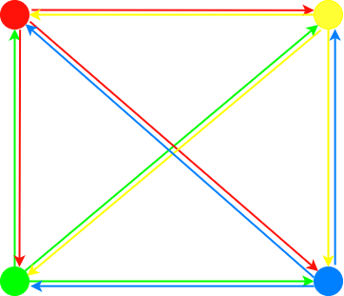

**Figure 2.** Possible transitions between four viewing positions

The maximum number of transitions, if each position is accessible to others, can be calculated according to formula (3):

|  |  |
| --- | --- |
|  | (3) |

*nMaxAvg* is the maximum number of video transitions. *nPos* parameter is the number of viewing positions.

If a scene lasts one minute, there are 6 viewing positions, you can move freely in all directions, and the transition lasts one second - it is necessary to generate a total of 1800 one-second videos. The number and size of the transition videos depend on the number of transition directions, the duration of the transitions and the total duration of the scene. For the example case, the total file size of the transitions is:

1800 * 25 / 8 = 5625 Mb = 5.625 Gb for a bandwidth of 25 Mbps;

1800 * 60 / 8 = 13500 Mb = 13.5 Gb for a bandwidth of 60 Mbps;

1800 * 100 / 8 = 22500 Mb = 22.5 Gb at 100 Mbps.

This large amount of transition videos increases the overall size of the program significantly. In order not to overload the system, the number of viewing positions, the distances between them and the number of accessible directions must be optimised. Optimisation can be achieved by reducing the number of transitions or the bandwidth. If we reduce the number of transitions, we reduce the possibilities of movement so that engagement suffers, but not image quality. If we want to keep a wide range of movement, it is worth reducing the bit rate, but this can lead to artefacts in the transitions and a drop in image quality, and thus in inclusiveness.

**Methods of video transitions**

During transitions between two viewing positions, the panoramic videos shown in two-dimensional scenes are changed in a specific way. In order to simulate six degrees of freedom movement, changing panoramic videos should look as natural as possible and cause as little discomfort to the user as possible. After changing a panoramic video with another one, it should continue from the same point in time. It is also important, that the transition is not jerky during the process of changing videos, so that a seamless representation of the scene is maintained. Our application implements three methods of video transitions, simulating movement between viewing positions: clipping, blending and sequential.

**Changing videos by clipping**

Replacement of the video shown by clipping is a simple and frequently encountered practice. After approaching the next viewing position, the displayed panoramic video is changed to another one which continues to play from the point of crossing. This should allow achieving a smooth transition.

When the user moves to a position in space that requires changing a scene, the time point of the video is memorized, and the video is paused. The panoramic video player loads a new video, decodes it, seeks a video position of the memorized time point, and plays it (see Fig. 3). Normally, this results in a jerky transition because opening another video, buffering and decoding it requires some time and the view freezes during these operations. This impacts the transition smoothness and integrity of the scene.

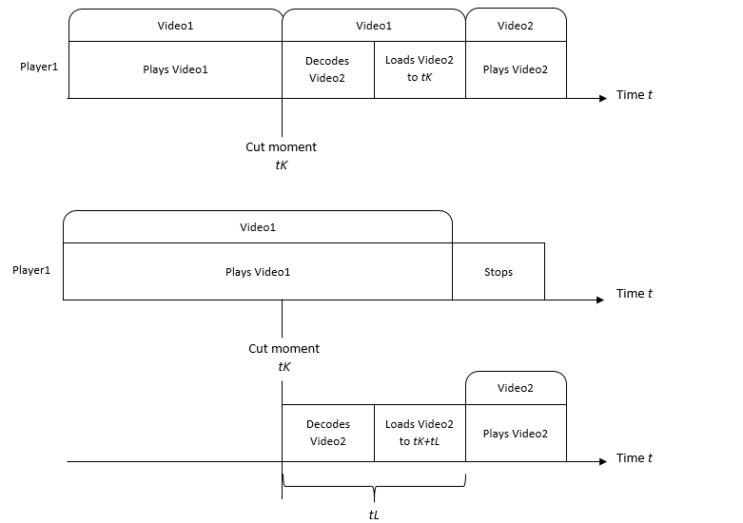

**Figure 3**. The process changing videos by clipping

This can be solved by using two panoramic video players so that these operations can be processed beforehand.

This time, when the user moves to a position in space that requires changing a scene, the first player continues to play a video of the initial viewing position until another player finishes preprocessing a video dedicated to another viewing position. The decoding of the new video and seeking memorized video position takes a *tL* amount of time. It is important to start playing and rendering the second player view only when the preprocessing of the new video is completed. The decoding and seeking time depends on the computational capabilities of the VR system. The preprocessing time *tL* could be predicted by registering *tL* values for each transition and calculating the average.

**Changing videos by blending**

Blending two panoramic views (normally – panoramic images) is also a common technique used by panoramic software. In our case, as a new viewing position was approached by the user, there is a given time interval (*tS*) to change the pixel transparency values of the initial and the new video. As time passes, the initial video values become fully transparent, and the new video values become fully visible. This method uses two players and plays the video from both players during the blending process (see Fig. 4). The fusion method is smoother than the clipping method and potentially less disorienting, as the user sees the overlapping pixels during the fusion of the videos. However, this method requires a higher performance of the computing equipment since players are playing two videos during the transition.

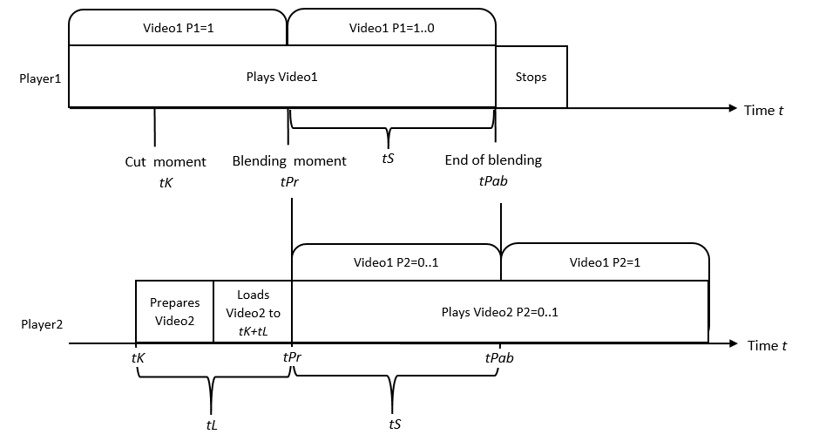

**Figure 4**. The process of blending panoramic videos.

There is an open question that requires additional study – how long should blending occur? A very short duration of this transformation means that fusion occurs very quickly. It can go unnoticed by the user and produce the same effect as the cut-off method. However, two players playing at the same moment for a prolonged time may affect the performance of the system.

**Sequential transition using prie-generated videos**

The transition method proposed in this work is performed by playing a pre-generated video of a certain duration. This video simulates movement between two viewing positions. It looks as if a user would be filming while moving from one position to another. We call this method sequential because we use a sequence of prie-generated videos.

The scene video duration t is divided into segments of transition duration *tT* that sequentially follow each other (Fig. 5). At each transition between viewing positions in both directions, *t/tT* transition videos are generated, each occurring at time *k*tT*. As a very large number of videos need to be generated, the overall size of the application increases significantly, which can create difficulties when using limited-memory mobile VR renderers.

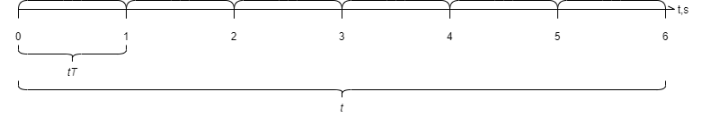

**Figure 5**. The Distance covered during the transformation.

When simulating user movement with a video, it is important to take into account the duration of the generated transitions as well as the distances between viewing positions. As the user moves in space, the transition time between positions should be matched as closely as possible. It is also important that the distance covered during the transformation is the same as in VR and that vestibular dissonance is minimised.

Two players are used during the transition (see Fig. 6). One plays the videos dedicated to viewing positions, and the other plays a video of movement transition. When the user moves to a position that requires changing a scene, the movement transition video is selected according to the playback time (*tK*) of the current video (*Video1*). The movement video (*VideoP*) is loaded in the player dedicated to the transformation. During the movement video playback, the video (*Video2*), dedicated to the destination viewing position, is loaded in the first player. It proceeds to play a video from the last time frame of the movement video. It is important that the decoding and seeking operations of the destination video (*Video2*) take less time than the duration of the movement video. Otherwise, the synchronization of movement and destination videos would fail. This reduces the immersiveness and integrity of the displayed video scenes.

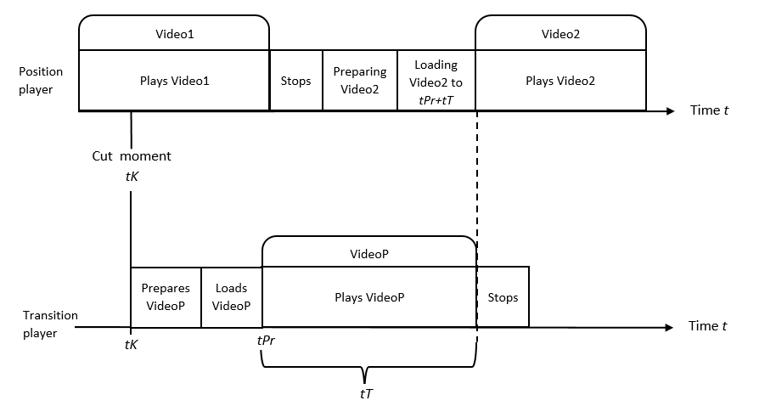

**Figure 6**. Implementation of sequential transition using two video players.

The transformation can also be implemented using three panoramic video players (see Fig. 7). In this case, the movement and destination videos could be simultaneously loaded in respective players. The advantage of this implementation is that the loading of the destination video becomes independent of the duration of the movement video. No matter how small the video is, the second video will always have time to load. However, it is necessary to use the third video player, which means additional resource usage. This implementation has been explored, and it was noticed that this approach significantly reduces the stability of the system. We abandoned this approach in our study, but it can be used on high-end VR equipment.

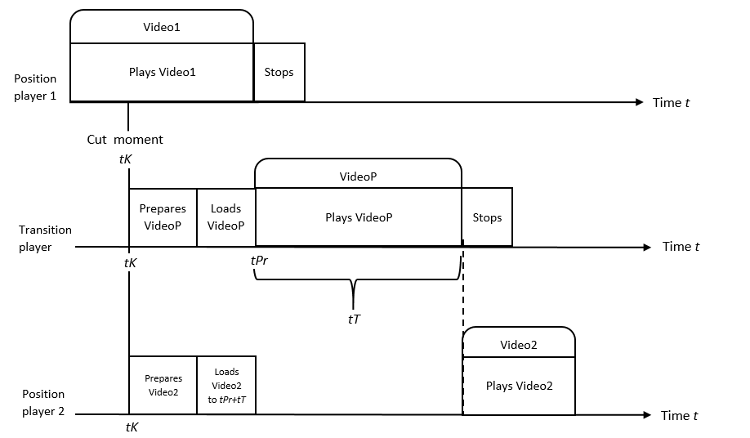

**Figure 7**. Implementation of sequential transition using three video players.

2. Evaluation

This work proposes a method for using pre-rendered stereoscopic panoramic videos of detailed three-dimensional scenes, allowing movement between spatially positioned viewpoints. For changing the viewing position, we proposed clipping, blending and sequential transitions, simulating a movement and immediate transition in three-dimensional space.

We make an assumption that this method allows the creation of high-fidelity dynamic VR content suitable for use on simple devices with limited capacity, in contrast to three-dimensional content dedicated for limited-capacity devices, without compromising the sense of presence. The proposed method should maintain a greater sense of presence than conventional methods of transition between panoramic videos.

To confirm or refute this assumption, experimental studies were carried out by testing a group of subjects and evaluating the proposed method in terms of the usability of the content, the sense of presence, the adverse physiological effects and the impact on the performance of the rendering equipment. For this purpose, we implemented conventional methods for rendering and navigating three-dimensional and two-dimensional content, as well as a proposed method.

Another goal of the experiments was to evaluate whether the proposed two-dimensional content rendering method is the most pleasant to use and can compete with three-dimensional content rendering. Therefore, the experiments in the study evaluate the usability, performance and sense of the presence of each implemented two-dimensional VR content rendering method. At the same time, these properties were also evaluated for the three-dimensional VR content. During the experiments, the system collected performance data. After performing certain tasks in the virtual environment, the surveys were completed to assess the usability of the rendering methods and the user's sense of presence in the environment.

The following experiments are carried out:

1. System usability evaluation - subjectively assessing the ease of use using a System Usability Scales [22] survey;
2. Sense of presence evaluation - subjectively assessing the sense of presence using Igroup Presence Questionnaire (IPQ);
3. Performance experiment - objectively assessing the impact of different detail levels of three-dimensional and two-dimensional VR content on the frame rate and stability.

*2.2. Ethical Considerations*

The paper was developed according to the institutional ethics requirements by following the requirements for researchers on ethics issues. The collected data doesn’t store any evidence to relate it to experiment participants.

*2.3. Data Collection*

No personal data was collected automaticaly by the software. The survey data was collected during the research implementation process and experiment by the researchers, whose reflections and the account of the process is also an important source of data used in the paper. During the survey, researchers administered questionnaires. The data of the same survey participant were related by using a random id chosen by the participants. There was no evidence registered that could be used to relate a person with survey data.

*2.4. Instruments Used*

There were three surveys presented to the participants. System usability scales [22] questionnaire was used to explore the system’s usability. The sense of presence was investigated using Igroup Presence Questionnaire (IPQ) [23]. Power BI software was used for statistical data analysis of the surveys.

3. Experiment results

*3.1 Usability testing*

The aim of the study is to evaluate the usability of two-dimensional methods for rendering VR content and the sense of presence they induce. The study aims to answer the following questions through experiments:

1. Which is the easiest method to use for video transitions occurring while changing camera positions?
2. Which navigational object, static lines or dynamic arrows, is preferable and more intuitive and easier to use?
3. Which method of video transition has the least negative physiological consequences and is more comfortable to use?
4. Does the two-dimensional content representation and locomotion using presented transitions induce a stronger sense of presence in the environment in comparison to other methods?

The content presented to the user during the experiments is a VR three-dimensional scene containing a single moving object. For presenting the two-dimensional content, the scene has six and twelve viewing positions. From each position, the user can move to the two adjacent positions. For each position, a stereoscopic top-bottom panoramic video was generated. The top part of the video was dedicated to the right eye and the bottom – to the left eye. The distance between the left and right cameras, specified at the time of generation, was 0,65 mm. The distances between the viewing positions were constant, and the viewing positions were arranged in hexagonal and dihedral patterns. In a scene with 6 viewing positions, the distances between them were 1 meter. The distances in a scene with 12 viewing positions were 0,52 meters (Fig. 8). Panoramic videos of viewing positions conform to the minimum requirements discussed. The videos were generated at a resolution of 3840x3840 pixels, using a frame rate of 30 frames per second. The duration of the videos generated is 30 seconds for all viewing positions. The animation is 30 seconds long as well. The animation is made in such a way that it can be repeated (the first and last frames are the same) without causing a jitter. The videos were generated at 12-bit bandwidth. The videos used for the transitions between viewing positions were generated by moving the camera from one position to another at a constant rate throughout the animation (720 videos in total for a 12-position configuration, 360 videos for a 6-position configuration).

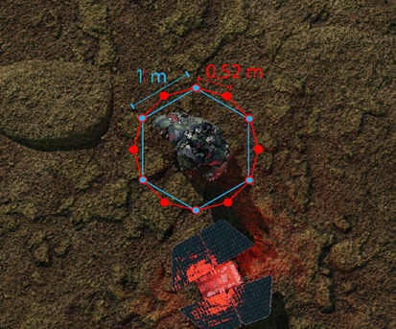

**Figure 8.** Location of viewing positions at shorter (0.52m) and longer (1m) distances

The duration of one transformation was set to 1 second. The parameters used in the configuration file during the rendering of two-dimensional content are shown in Table 3. The values were determined during manual testing, seeking to optimise the experience of moving in space, reduce the time between movement and application response, and make the transition as natural as possible. The *transition start* value represents the percentage of the distance between two adjacent viewing positions. A value of 0.5 means – the transition must start after the user passes the middle point of the path. Transitions should be performed if a user stays on the path. The *path width* parameter determines possible user deviation from the pre-determined path. The *Blending duration* parameter denotes how long the blending process will take place.

**Table 3.** Parameters used for two-dimensional content scene transition methods.

|  |  |  |  |  |  |  |
| --- | --- | --- | --- | --- | --- | --- |
|  | **Clipping** | | **Blending** | | **Sequential transition** | |
| 6 pos. | 12 pos. | 6 pos. | 12 pos. | 6 pos. | 12 pos. |
| **Transition start** | 0,5 | 0,7 | 0,5 | 0,7 | 0,3 | 0,3 |
| **Path width (m)** | 0,6 | 0,6 | 0,6 | 0,6 | 0,4 | 0,4 |
| **Blending duration (s)** |  | | 0,2 | |  | |

The application renders VR content using the Unity game engine. The total size of the application is 4,36 Gb (2,81 Gb of space is dedicated to videos). It requires a personal computer and a VR helmet or a VR helmet with an integrated processor for computing. Figure 9 depicts system deployment.

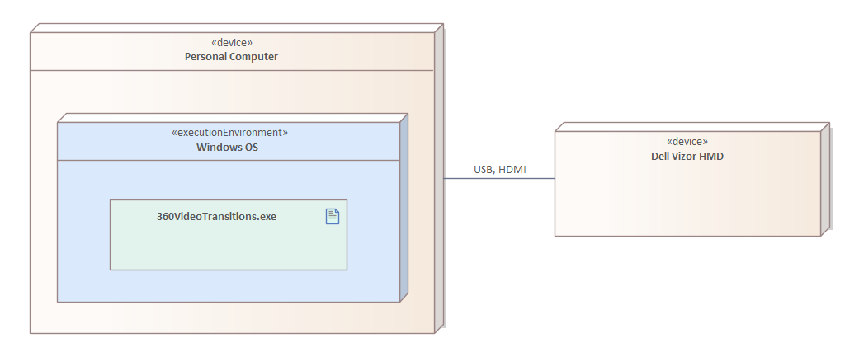

**Figure 9.** Deployment of the system used in the experiments.

Specification of the system components is provided in Table 4.

**Table 4.** Characteristics of the devices used in experiments.



|  |  |
| --- | --- |
| **Component** | **Characteristics** |
| **Processor** | Intel Core i7-8700K 3,7 GHz |
| **Graphics card** | NVIDIA GeForce GTX 1070 video processor |
| **Operating system** | Windows 10 |
| **VR device** | Dell Vizor Windows Mixed Reality |

A Dell Vizor Windows Mixed Reality VR device is connected to the computer. It sends user position information and displays the scene content. Control of the application was performed by the researcher using a keyboard connected to a PC. The viewing positions were arranged in the space of 2 square meters. Overall, the 2,5 square meter area has been prepared for free navigation, taking into account the user’s possible deviation from the intended path (Fig. 10).

2 m.

2 m.



Researcher



Participant

**Figure 10.** Experiment area configuration.

The experiment involves presenting a dynamic scene to participants using a VR headset. The scene is rendered using three-dimensional (using three-dimensional models) and two-dimensional (using panoramic video) methods. If the scene is rendered in two dimensions, one of the three presented methods for transition is used. The experiments were performed four times, with at least a 10-minute break between experiments. Each time, data was collected for a specific method:

1. Two-dimensional, which uses clipping for transitions;

2. Two-dimensional, which uses blending for transitions;

3. Two-dimensional, which uses the proposed sequential transition approach;

4. Ordinary three-dimensional, which uses built-in “room scale” transitions.

Due to the pandemic, additional conditions were imposed on the experiment. The experiments were carried out in a closed room with ventilation throughout the experiment. Two people were present in the room at the same time: a participant and a researcher. After each experiment, the empty room was ventilated for an additional 10 minutes and all surfaces, including the VR helmet, and keyboard, were disinfected. Participants were allowed to enter the room wearing masks only and disinfecting their hands with hand sanitisers on entering and leaving the room.

The experiment protocol is depicted in Figure 11. On the left side of the figure, one can see the modes of the application that were used to perform the experiment each time. The right side of the figure depicts the flow of actions the researcher and participant need to perform during each phase of the experiment.

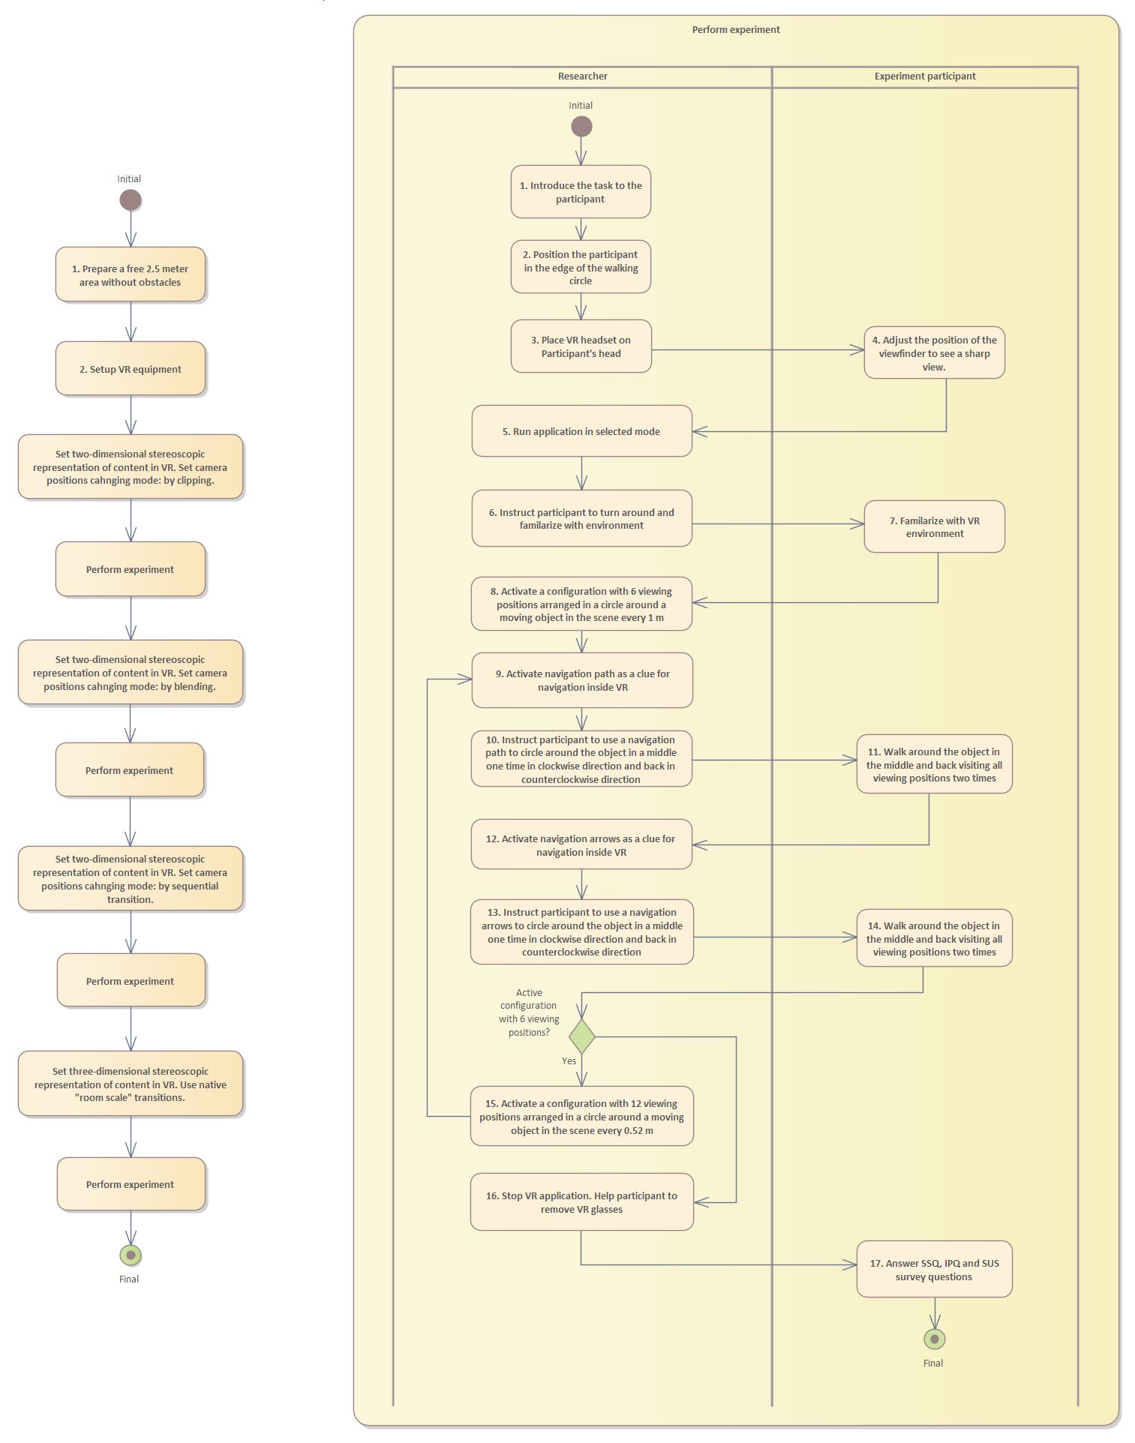

Figure 11. Experiment protocol flowchart

In total, 18 responders took part in the experiment: 8 women and 10 men. The age of the participants varied from 20 to 48 years old. We divided the participants into three groups. The age group under 25 years old accounted for the largest number of participants - 50%. 22.22% of the participants belonged to the age group between 25 and 30 years old. The over-30 age group accounted for 27.78%.

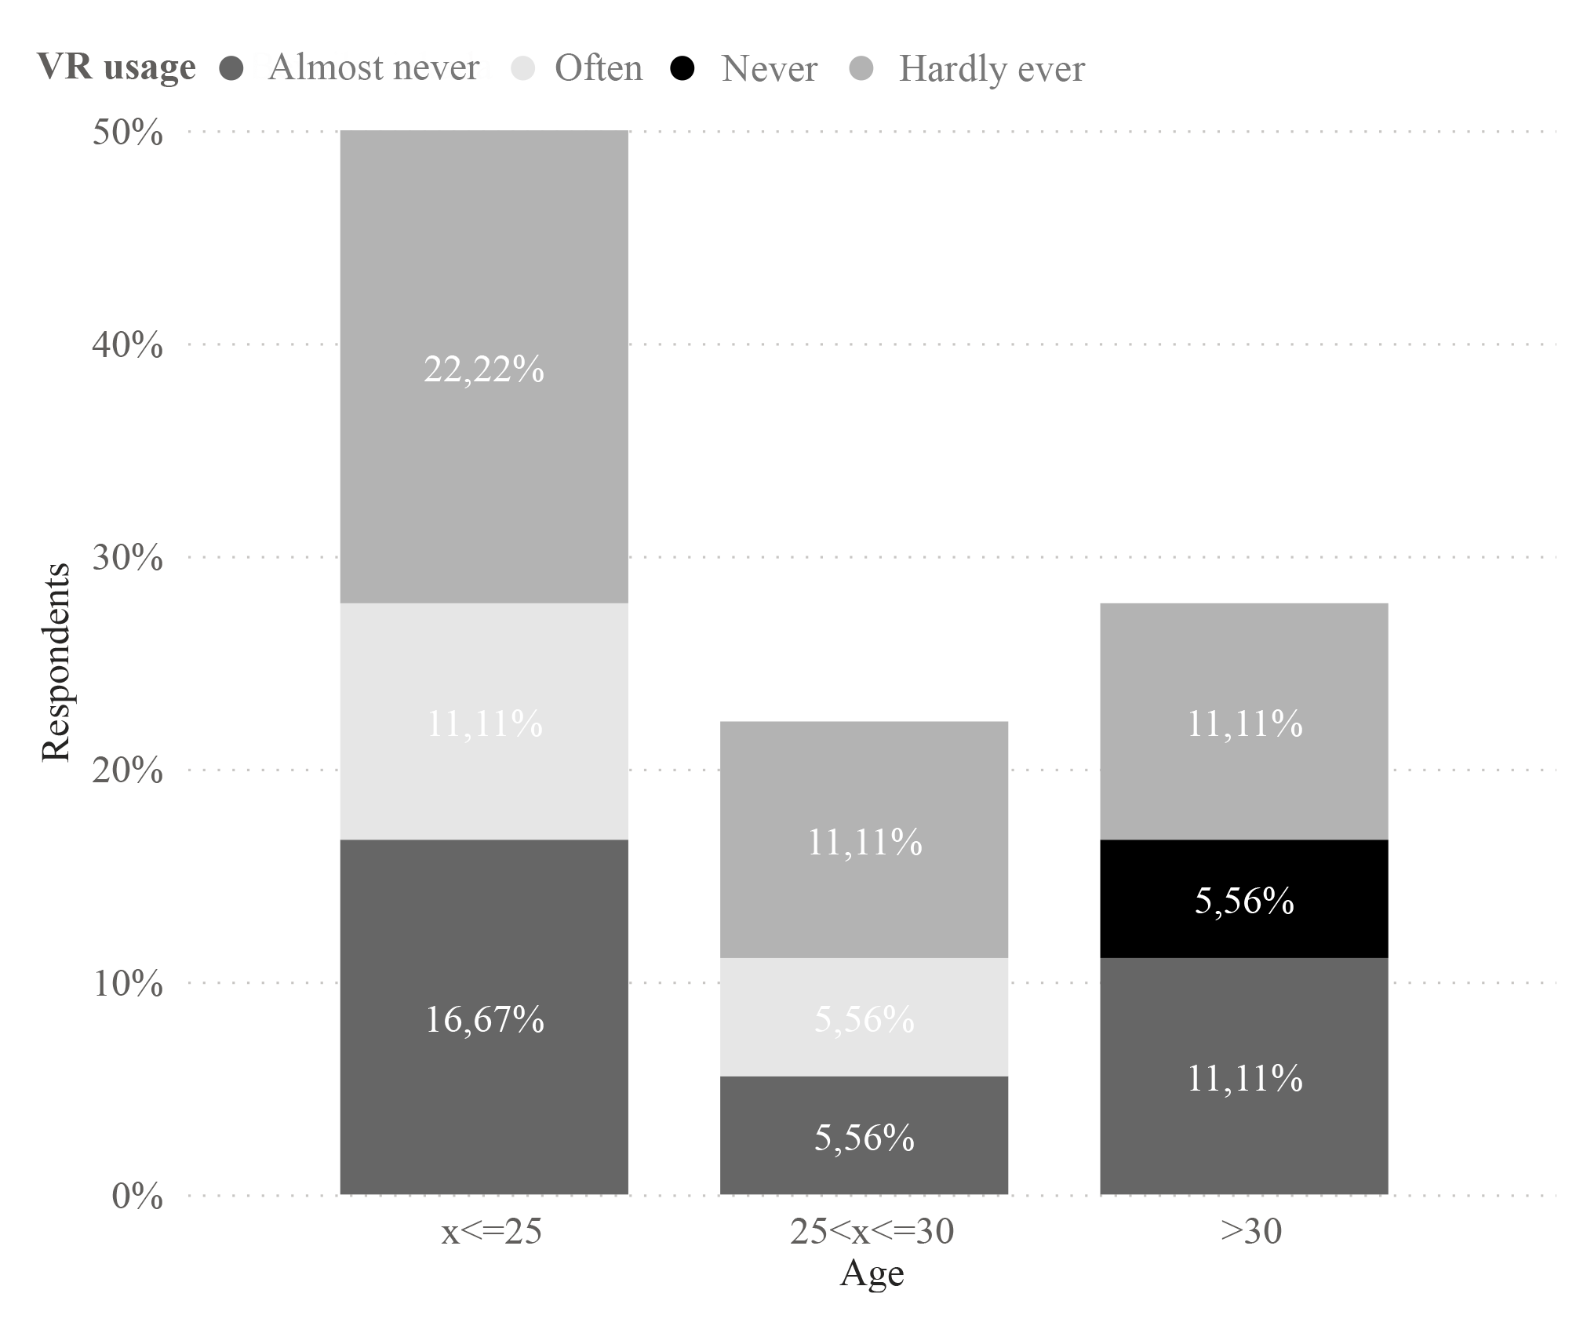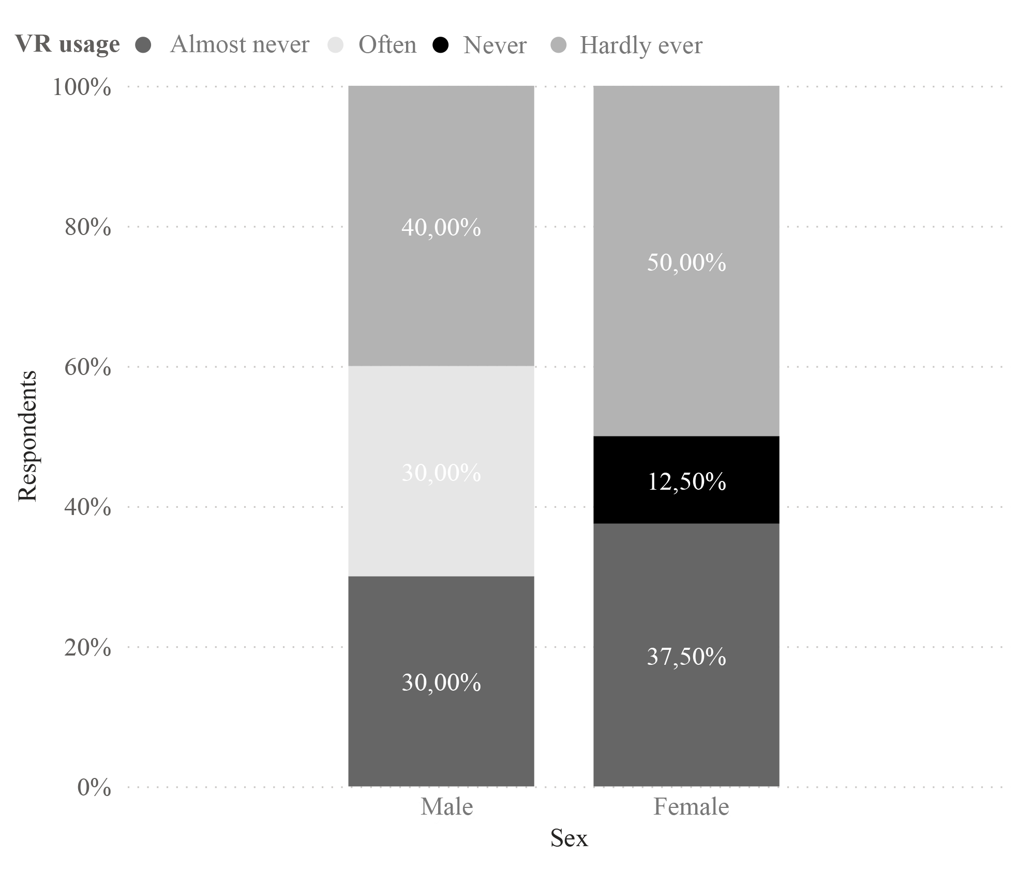

|  |  |
| --- | --- |
| **Figure 12**. VR usage by gender | **Figure 13**. VR usage by age |

The baseline survey on VR usage habits showed that 44.44% of respondents use VR occasionally, 33.33% almost never, 5.56% (one respondent) never and 16.67% often. As many as 30% of the male respondents reported using VR frequently and only 30% of the male respondents reported using VR almost never. In contrast, as many as 50% of the women said they hardly ever or never use VR and none of the women use VR often (Fig. 12). Looking at VR usage habits by age of users, the most frequent VR users are under 30 years old and the least frequent VR users are over 30 years old (Fig. 13). The data show that men and people under 30 are more likely to use VR.



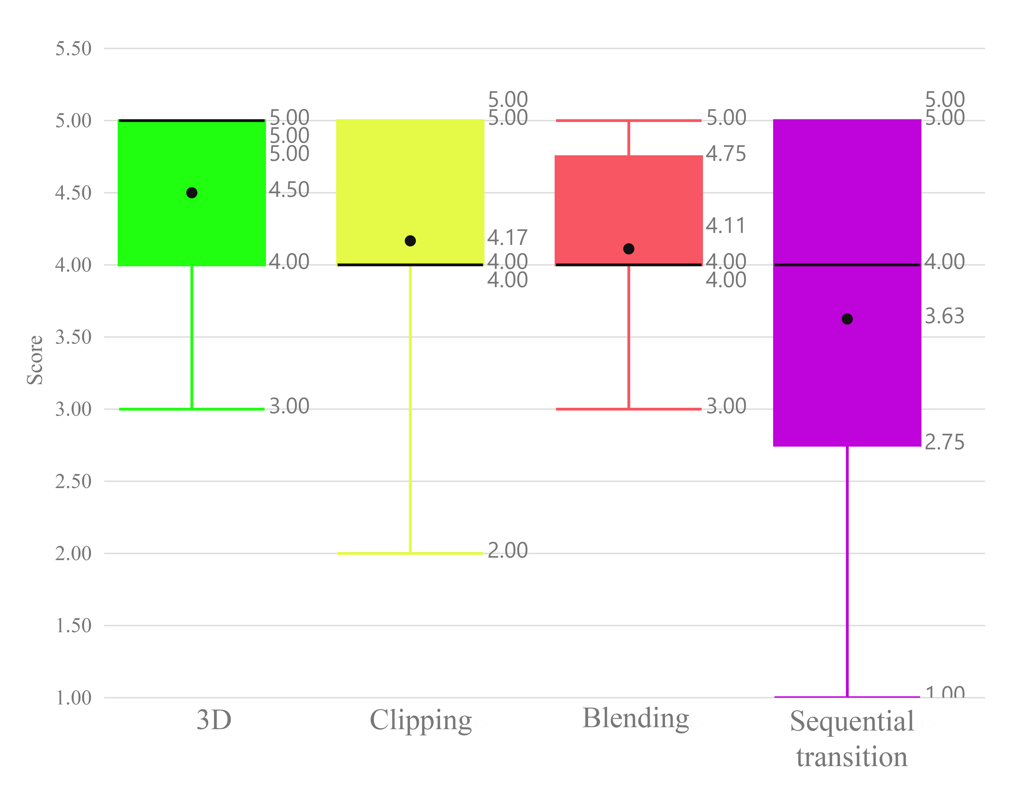

Figure 16: Distribution of the VR experience ratings (1-very bad, 5-very good).

Each time a task was performed in VR with a particular content rendering method, users rated how much they enjoyed the experience. The distribution of ratings (see Fig. 16) shows that not a single two-dimensional method was rated better than a three-dimensional method, although the three-dimensional scene had a much lower level of detail. This may have been influenced by unrestricted movement. Among the two-dimensional methods, the clipping and the blending methods had similar scores. A higher proportion of respondents rated the clipping method with the highest rating (5) in comparison to the blending method. However, the lowest rating of the clipping method is lower than the lowest rating of the blending method. The blending method was the most consistently rated method. The method that sequential approach was the least consistently rated method. The majority of the scores for this method range between 2.75 and 5.



For two-dimensional content, we evaluated the acceptability of distance between viewing positions for each transition method. The graph (Fig. 17) shows a trend that the majority of respondents (66.67%) preferred smaller distances between viewing positions in the clipping and blending methods. However, for a sequential transition approach, the distribution of distance preference is equal.

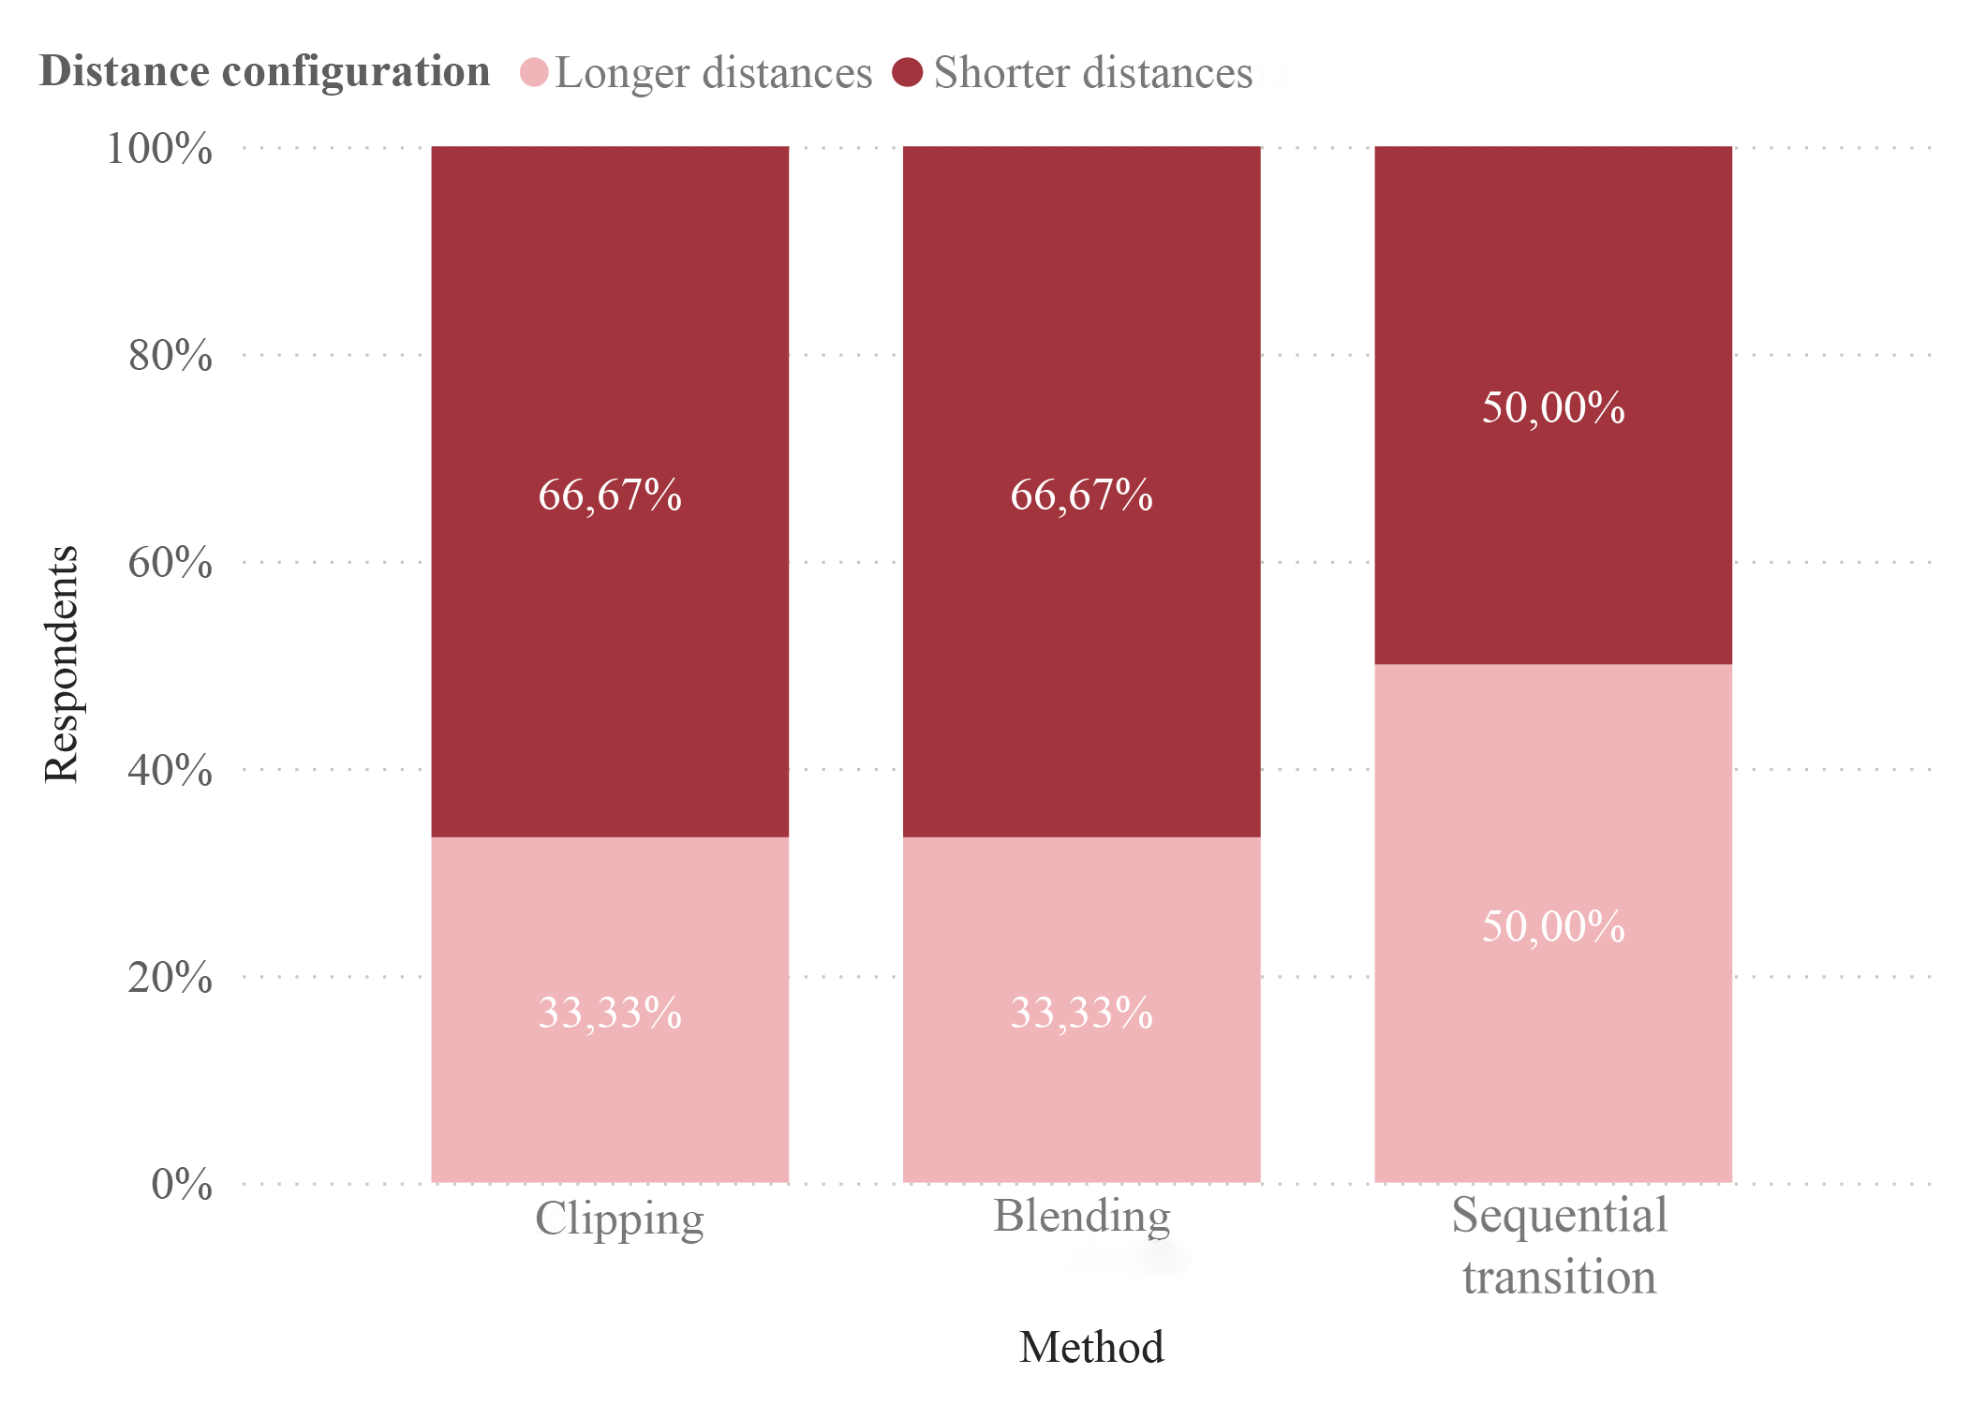

Figure 17. Distribution of distance choices for each two-dimensional transition method

From the distance ratings obtained for the two-dimensional transition methods presented in Table 6, it can be seen that short distances are more favourably rated than long distances for both clipping and blending methods. However, for the sequential transitions, there is only a slight difference between the mean estimates of short and long distances. Still, the standard deviation shows that these estimates are the most different. The ratings of clipping and blending methods give priority to shorter distances, possibly because, in this case, the user perceives a discrepancy between his/her movement and the visible image for a shorter time. For the sequential approach, the priority for distances is low, possibly because the motion is seen when changing position.

**Table 6**. Estimates and standard deviations for long and short-distance.

|  |  |  |  |  |
| --- | --- | --- | --- | --- |
| **Method** | **Average for long distances** | **Standard deviation for long distances** | **Average for short distances** | **Short-distance stand. deviation** |
| **Clipping** | 3,61 | 0,83 | 4,00 | 1,05 |
| **Blending** | 3,44 | 0,83 | 4,11 | 0,94 |
| **Sequential** | 3,25 | 1,20 | 3,38 | 1,27 |

The preference is likely to depend on the individual respondent's movement speed and its correspondence with the movement speed of the camera in the video.

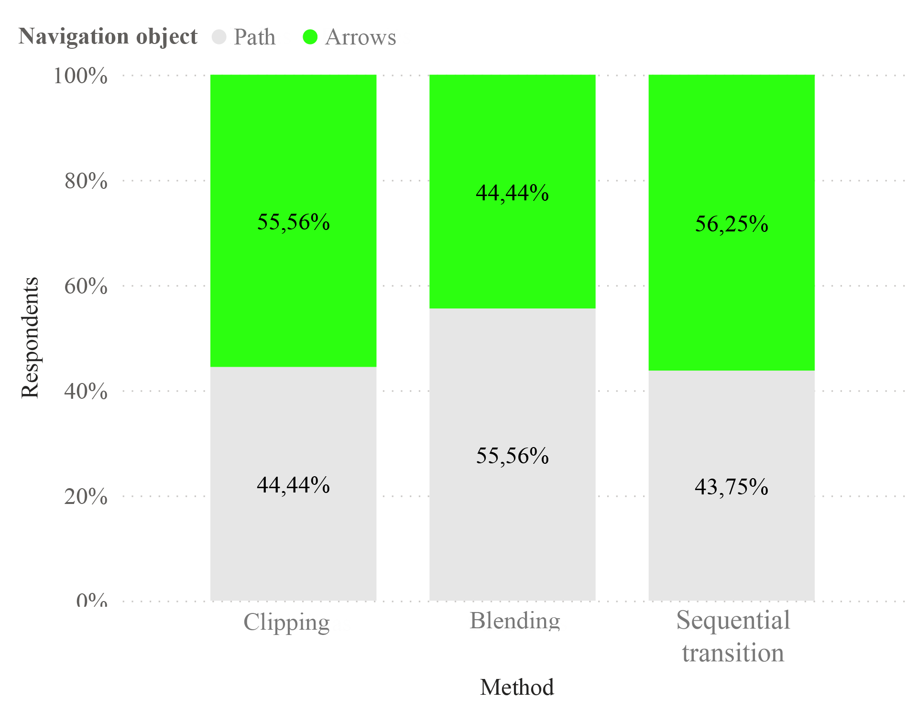

Figure 18. Distribution of navigation object selection in two-dimensional transition methods

The choice of the navigation object, static path and dynamic arrows is similar for the different methods (Fig. 18). However, it can be distinguished that the people who liked the blending method preferred the static path more often. As the image is blended when moving between viewing positions, seeing not only the direction but also the distance to be travelled to reach a clear image potentially reduces the occurrence of dizziness and makes users feel more confident. In contrast, people who prefer methods of clipping and sequential transition were more likely to prioritise the dynamic navigational object. While moving in a static line, without video refresh during video clipping, will more likely lead to nausea due to image-motion dissonance. In contrast, when using a dynamic object - an arrow - and seeing the direction but not the distance, the dissonance is potentially less. The reason for the increased popularity of the dynamic arrows in other methods may be the same. The transition shows a movement, while the arrows only show the direction of movement, causing less dissonance. In the case of a static path, it only moves when the user moves, so if the user stops at the start of a transition, so does the displayed road. This creates dissonance between the movement of the rendered images.

The path navigation object was indicated as best for the blending method and as worst for the sequential transition method (Table 7). Dynamic arrows showed the best result for the clipping method and the worst for the sequential transition method. Although the latter method has, on average, the worst estimates, the high standard deviation suggests that the distribution of estimates of navigation objects for this method is very wide. As the sequential transition is the worst-rated method for changing the viewing position, the estimation of navigational objects for this method may also have suffered as a result.

**Table 7**. Estimates and standard deviations of navigational objects used in two-dimensional methods

|  |  |  |  |  |
| --- | --- | --- | --- | --- |
| **Method** | **Average path navigation estimate** | **Stand. deviation of the path navigation estimate** | **Average of the estimates for dynamic arrows** | **Standard deviation of the dynamic arrows estimate** |
| **Clipping** | 3,83 | 0,96 | 4,00 | 1,00 |
| **Blending** | 4,11 | 0,94 | 3,78 | 0,97 |
| **Sequential** | 3,06 | 1,34 | 3,63 | 1,05 |

As for the usability estimates, a 95% confidence interval is calculated for each method (see Table 8). As the ranges of estimates for the two-dimensional content representation methods overlap, it is concluded that there is a 95 % probability that there is no statistically significant difference between the SUS estimates of the clipping, blending and sequential transition methods. They all fall within the good usability range (68-80.3). However, there is a 95% confidence that there is a statistically significant difference between two-dimensional and three-dimensional content representation, as the confidence intervals do not overlap. Also, the usability of three-dimensional content is 95% likely to fall into the category of excellent usability.

**Table 8**. Totally 95% confidence intervals for SUS estimates for all methods

|  |  |  |  |  |
| --- | --- | --- | --- | --- |
| **Method** | **Lower limit of the mean** | **Average** | **Upper limit of the average** | **Standard deviation** |
| **Clipping** | 69,4 | 76,3 | 83,2 | 15,9 |
| **Blending** | 73,9 | 80,4 | 86,9 | 14,7 |
| **Sequential** | 70,6 | 78,3 | 86 | 15,7 |
| **Three-dimensional** | 86,8 | 91,7 | 96,6 | 10,7 |

The chart (Fig. 19) gives an overview of the distribution of usability estimates according to the SUS survey. The three-dimensional method of displaying content is clearly the best-rated. The majority of the scores are distributed between 84.3 and 102.5, indicating that the usability of this method is excellent. The usability of the blending and sequential transition methods is distributed between good (73.13) and excellent (91.88). However, the mean score (78.28) for the sequential transition method is slightly lower than the mean score (80.42) for the blending method. The clipping method scored the lowest in this category. The 25th percentile of the estimate is on the borderline of moderate usability. Overall, the usability of all three two-dimensional VR methods is good. In contrast, the usability of the blending method ranges between good and excellent.

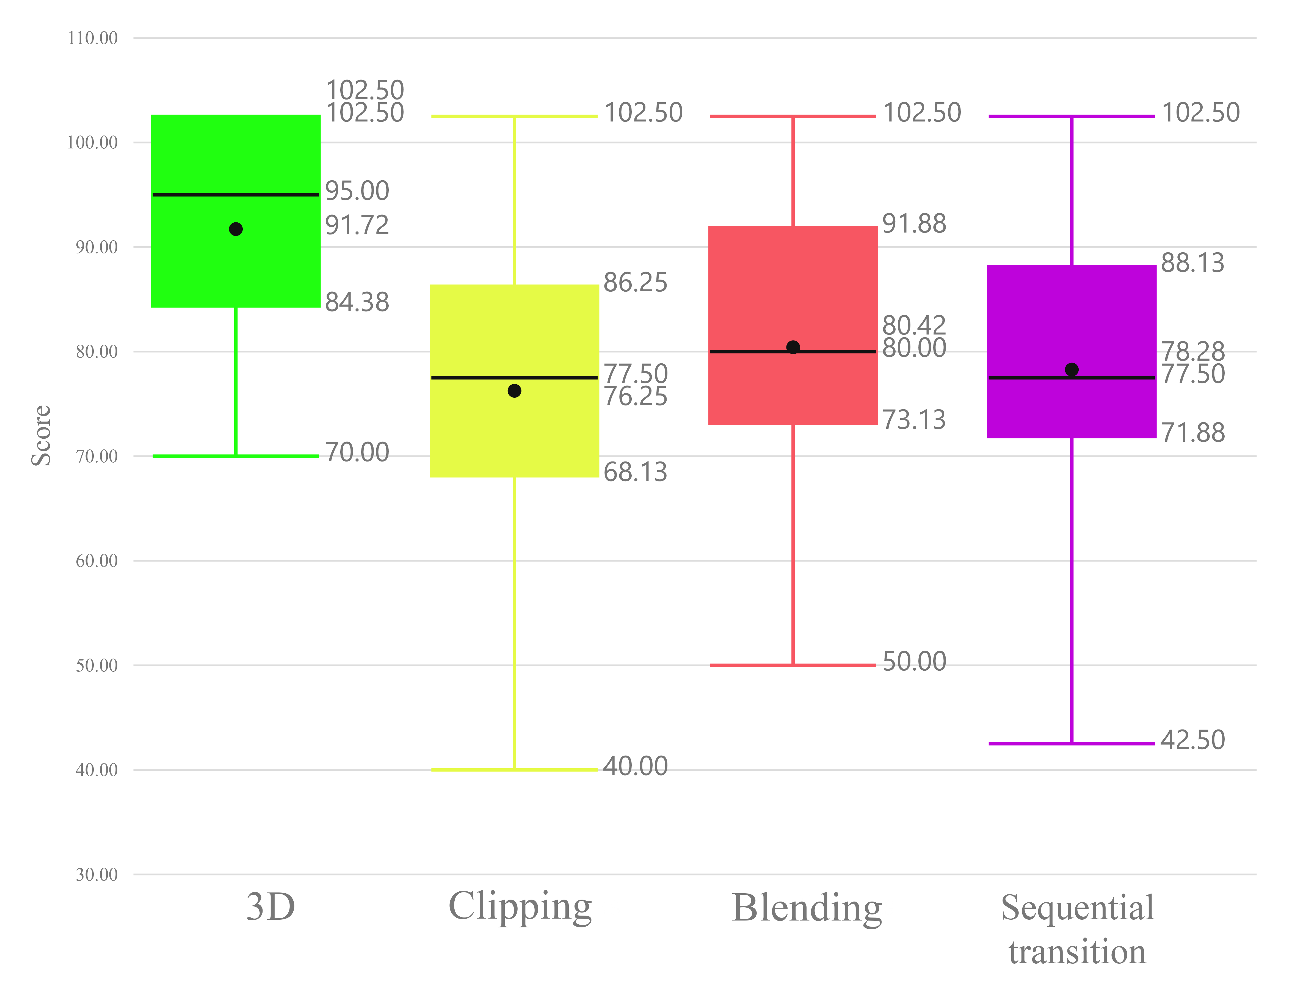

Figure 19. Distribution of system usability estimates for each method



The IPQ survey was used to assess the overall feeling of being in the environment.

**Table 10**. Cronbach's alpha coefficients of the IPQ scale items for the experimental data samples

| **Criteria** | **Spatial awareness** | **Immersion** | **Realism** | **IPQ** |
| --- | --- | --- | --- | --- |
| **Full application** | 0,748 | 0,763 | 0,64 | 0,861 |
| **Three-dimensional rendering** | 0,842 | 0,803 | 0,759 | 0,916 |
| **Two-dimensional, clipping** | 0,485 | 0,647 | 0,616 | 0,769 |
| **Two-dimensional, blending** | 0,826 | 0,643 | 0,693 | 0,846 |
| **Two-dimensional, sequential** | 0,619 | 0,808 | 0,232 | 0,729 |
| **Sample of variables** | 5 | 4 | 4 | 14 |

The internal consistency of this survey for the sample of data collected during the experiment is adequate for each method, with coefficients > 0.5 for a sample of fewer than 10 variables and more than 0.7 for a sample of more variables measured. From the coefficients presented in Table 10, it can be seen that almost all coefficients indicate internal consistency. The only IPQ variable for which the internal consistency is too low is the realism induced by the proposed two-dimensional method.

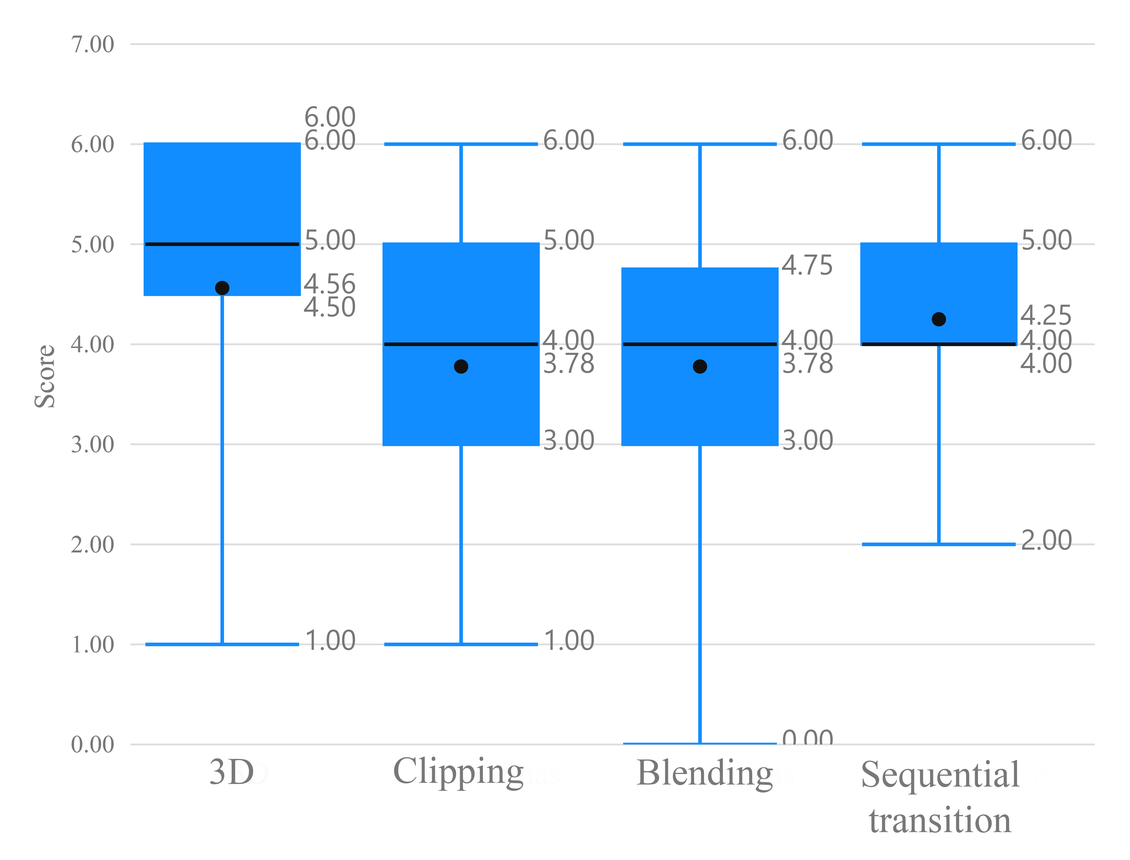

Figure 22. Sense of presence ratings for different content representation methods

The distribution of the data shown in the figure (Fig. 22) shows that three-dimensional content in VR produces, on average, the highest sense of presence in space (4.56). Among the methods of displaying two-dimensional content, the sequential transition provides the greatest sense of presence. It has the lowest range of estimates and the highest mean (4.25). The lowest-scoring method in this category is the blending method, with the clipping method scoring slightly better.

When it comes to the elements of the sense of presence in virtual space (engagement, spatial perception of presence, realism), three-dimensional content scored the highest on average in all categories. Among the two-dimensional methods, immersion criteria scored on average highest for the blending method, while spatial awareness and realism scored on average higher for the proposed sequential transition method.

**Table 11**. Statistics of the Sense of Presence survey estimates

|  |  | **Average** | **Stand. Error** | **Stand. Deviation** | **Variation** |
| --- | --- | --- | --- | --- | --- |
| **Sequential transition** | **Immersion** | 12,94 | 0,755 | 3,021 | 9,129 |
| **Spatial awareness** | 17,69 | 0,902 | 3,610 | 13,029 |
| **Realism** | 10,69 | 0,700 | 2,798 | 7,829 |
| **Clipping** | **Immersion** | 11,83 | 0,825 | 3,502 | 12,265 |
| **Spatial awareness** | 16,72 | 0,803 | 3,409 | 11,624 |
| **Realism** | 10,11 | 0,449 | 1,906 | 3,634 |
| **Blending** | **Immersion** | 13,44 | 0,525 | 2,228 | 4,967 |
| **Spatial awareness** | 17,61 | 0,714 | 3,031 | 9,193 |
| **Realism** | 10,66 | 0,681 | 2,890 | 8,353 |
| **Three-dimensional content** | **Immersion** | 14,35 | 0,821 | 3,285 | 10,796 |
| **Spatial awareness** | 19,43 | 1,004 | 4,016 | 16,129 |
| **Realism** | 11,56 | 0,741 | 2,965 | 8,796 |

The sense of spatial presence seems to be most favoured in the three-dimensional mapping method (Fig. 23). Among the two-dimensional methods, sequential transition again scores the highest. Although the range of most of the blending estimates is noticeably lower than for sequential transition, the averages for both are very similar (17.61 and 17.69, respectively). The lowest-scoring method in this category is the clipping method, although the average (16.72) is not far behind the latter two.

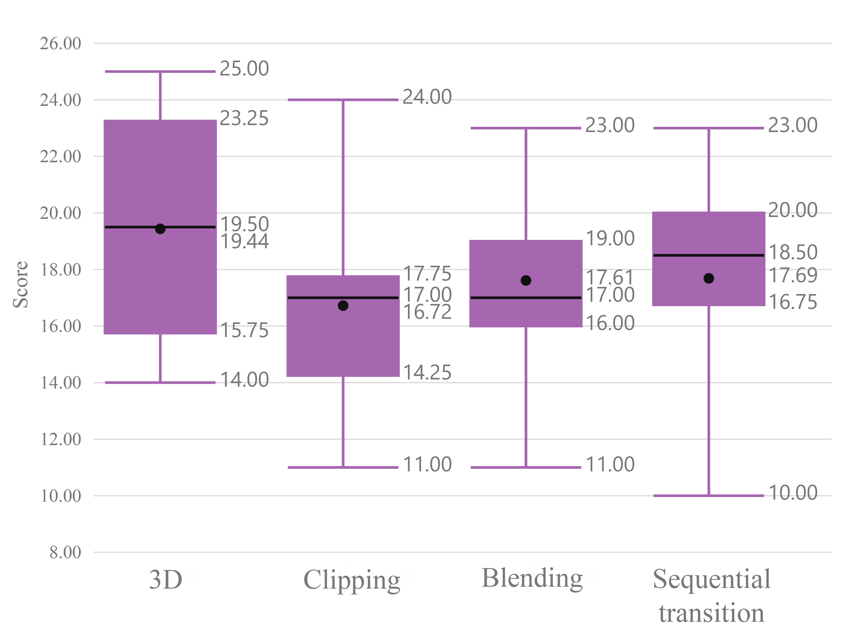

Figure 23. Spatial sense of presence ratings for different methods

The immersion chart shows that the three-dimensional method scores best (Figure 24). Among the two-dimensional methods, blending has the highest score range (12-15) and the highest mean (13.44). The sequential transition has a wider range, indicating more distinct estimates. Although the distribution of ratings is more stable, the clipping has lower ratings and, therefore, a lower mean than the sequential transition (11.83 and 12.94, respectively). The blending method scored the highest, possibly because, when displaying the content, the user not only sees the overlapping visual destination but also controls the brightness of the destination when moving towards it.

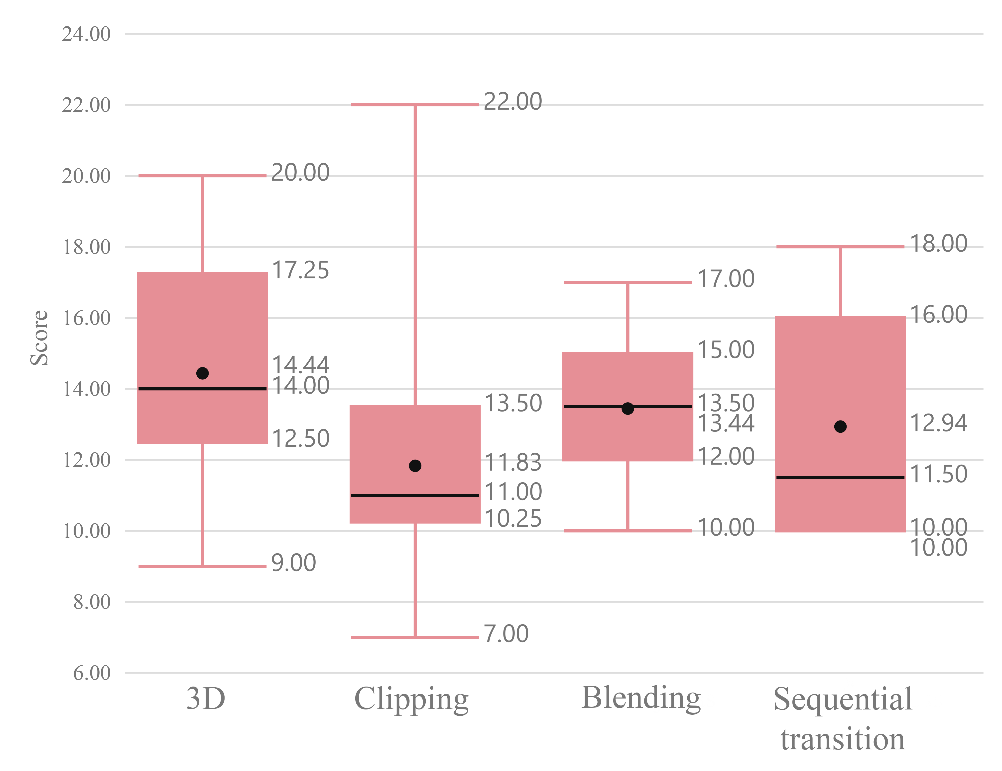

Figure 24. Immersion ratings for different methods

The graph for the assessment of the sense of realism shows that the two- and three-dimensional distributions of method scores are very similar (Fig. 25). The most notable method is the clipping method, which has the most stable distribution of estimates, albeit in the lowest range of estimates. This method has the lowest average realism score (10.11). This can be explained by the absence of a coherent transition, which has a noticeably large impact on the perception of realism. The sequential transition method scores best in this category. The implemented transition between viewing positions is coherent and seamless.

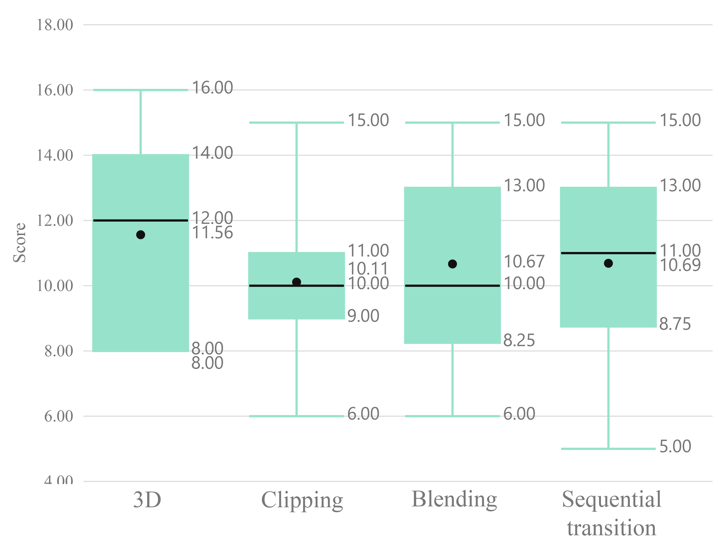

Figure 25. Ratings of the sense of realism for different methods

The experiment found that all two-dimensional methods of content representation are usable. The blending method slightly outperforms the sequential transition and clipping methods. It is preferable to use dynamic navigation arrows for sequential transition and clipping methods, while a static path is preferable for the blending method.

*3.2 Performance testing*

During this study, we evaluated the performance of 3D and 2D VR rendering methods. We recreated the same VR content that was used for the usability testing:

* higher-quality three-dimensional scene composed of 585182 triangles;
* lower-quality three-dimensional scene composed of 95510 triangles;
* two-dimensional scene for demonstration of sequential transition.

All experiments were carried out with the VR helmet Oculus Quest 2 and PC of the same specifications as described in Section 3.1.

We utilized the following experimental protocol:

1. The researcher turns the PC on, connects the rooter, and configures the local network;
2. The researcher turns the Oculus Quest 2 on, connects it to the local network, sets the VR device tracking area of 2.5 m;
3. The researcher installs the 360VideoTransitions application into the VR device;
4. The researcher starts the VideoController application and configures the settings for Oculus quest 2.
5. The participant stands near the middle of one of the edges of the VR device tracking area;
6. The researcher turns on the 2D scene with sequential transition, which is set to 6 viewing positions with a 1-meter distance between every two positions;
7. The participant is instructed to circle around the moving object, changing the viewing position 6 times (from 1st to 2nd, from 2nd to 3rd, ..., from 6th to 1st);
8. The participant is instructed to repeat instruction no. 7 in reverse order;
9. The researcher turns on the lower-quality 3D scene with unrestricted movement;
10. The participant is instructed to circle around the moving object in two opposite directions;
11. The researcher turns on the higher-quality 3D scene with unrestricted movement;
12. The participant is instructed to circle around the moving object in two opposite directions once again;
13. The researcher turns off the experimental equipment;

The frame rate was measured as the participant was carrying out instructions no. 7, 8, 10, and 12. The distribution of the frame rate for every experiment is presented in Fig. 26.

Figure 26. 2D and 3D content frame rate distribution

The data shows that the two-dimensional scene that uses the sequential transition ensures a stable frame rate of around 72 FPS. The average frame rate for the lower-quality three-dimensional scene is approximately 60 FPS. However, it is not stable since the lower bound of the boxplot reaches 23 FPS. The VR device is not able to produce a reasonable frame rate for a higher-quality 3D scene.

4. Conclusions

The analysis of existing content creation methods has identified that the two major approaches are the creation of three-dimensional scenes or using panoramic scenes with two-dimensional content (pictures or videos). The three-dimensional scenes can enjoy a high level of interactiveness and use unrestricted movement. On the other hand – the creation of three-dimensional scenes is expensive and time-consuming. Panoramic scenes usually do not provide the possibility to move around, although it is relatively easy and fast to create them. Therefore, our research focused on implementing and studying movement methods dedicated to panoramic content.

A methodology was proposed that combines modelling and video production. The methodology enables constrained movement in six degrees of freedom in prescribed directions between viewing positions. We proposed and studied three methods transition methods (clipping, blending and sequential) that are applied when changing a viewing position. The proposed methodology is thus assumed to reduce the computational cost of detailed content representation by simulating 6 degrees of the freedom movement.

We faced the problem of a seamless transition between different videos, as a certain amount of time is needed to decode and play a video. To overcome this problem, the system was designed in such a way that the required videos are loaded in advance before the transitions take place. Multiple players are utilised to play them. In this way, a smooth video transition was ensured.

Experimental studies assessing the usability, immersiveness and performance of the proposed methodology have shown:

1. According to the survey, the sequential transition method provides a lower sense of presence than modeled three-dimensional scene, which provides six degrees of freedom. This, therefore, refutes the hypothesis that the proposed method can maintain the same immersiveness as a three-dimensional scene;
2. When comparing the proposed sequential transition with methods that do not provide a coherent transition between viewing positions, overall presence, spatial awareness and realism of the sequential transition method were evaluated better.
3. The experiments showed an above-average estimate of the usability of the sequential transition method (estimate: 78.28) but no statistically significant difference between its usability and that of conventional two-dimensional methods (clipping and blending).
4. When assessing the performance of three-dimensional scenes and panoramic video approaches, it was found that only the panoramic video realises detailed content at a stable rate.
5. The study of the two proposed navigation objects (dynamic arrows and static path) for the sequential transition method did not show an advantage of any navigation approach. Also, no advantage was found for the two studied distances between viewing positions.

As we noted in the first conclusion, our attempt to find a middle ground between the creation of expensive and time-consuming three-dimensional scenes and the creation of relatively cheap panoramic video scenes that don’t allow unrestricted movement failed. The proposed solution can not maintain the same immersiveness as a three-dimensional scene, despite the better graphics. So, the question remains open – is it possible to achieve a similar immersiveness as a three-dimensional scene using other approaches? On the hand, the proposed simulated movement showed some promise. In our next research, we will try to improve immersiveness by producing and using depth maps for panoramic videos. This will allow responding to any movement of the user while remaining inside a viewing position. This approach will use transitions between scenes, as well.

**Author Contributions**

Conceptualization, AP; methodology, AP, AS; software, AP and AS, TB; data curation, AP, AS, MV; writing — original draft preparation, AP, AS, MB, CC DB, LP; writing — review and editing, TB, MB, MV; visualization, AP, AS and TV.. All authors have read and agreed to the published version of the manuscript.

**Funding**

This research was funded by Kaunas University of Technology.

**Institutional Review Board Statement**

Ethical review and approval were waived for this study, as this study involves no more than minimal risk to subjects.

**Informed Consent Statement**

Informed consent was obtained from all subjects involved in the study.

**Data Availability Statement**

The data presented in this study are available on request from the corresponding author. The data are not publicly available due to the data restriction policy by the grant provider.

**Conflicts of Interest:** The authors declare no conflict of interest.

References

1. Boletsis, C., & Cedergren, J. E. (2019). VR locomotion in the new era of VR: an empirical comparison of prevalent techniques. Advances in Human-Computer Interaction, 2019.
2. Takatori, H., Yano, H., & Iwata, H. (2015). Panoramic movie-rendering method with superimposed computer graphics for immersive walk-through system. In Haptic Interaction (pp. 277-284). Springer, Tokyo.
3. Kim, Y. M., Lee, Y., Rhiu, I., & Yun, M. H. (2021). Evaluation of locomotion methods in VR navigation environments: An involuntary position shift and task performance. International Journal of Human-Computer Studies, 155, 102691.
4. Soler-Domínguez, J. L., de Juan, C., Contero, M., & Alcañiz, M. (2020). I walk, therefore I am: a multidimensional study on the influence of the locomotion method upon presence in VR. Journal of Computational Design and Engineering, 7(5), 577-590.
5. Cherni, H., Métayer, N., & Souliman, N. (2020). Literature review of locomotion techniques in VR. International Journal of VR.
6. Mayor, J., Raya, L., Bayona, S., & Sanchez, A. (2021). Multi-technique Redirected Walking Method. IEEE Transactions on Emerging Topics in Computing.
7. Cherni, H., Nicolas, S., & Metayer, N. (2021). Using VR treadmill as a locomotion technique in a navigation task: Impact on user experience–case of the KatWalk. International Journal of VR, 21(1), 1-14.
8. Rantala, J., Kangas, J., Koskinen, O., Nukarinen, T., & Raisamo, R. (2021). Comparison of controller-based locomotion techniques for visual observation in VR. Multimodal Technologies and Interaction, 5(7), 31.
9. Paris, R. A., Buck, L. E., McNamara, T. P., & Bodenheimer, B. (2022, March). Evaluating the Impact of Limited Physical Space on the Navigation Performance of Two Locomotion Methods in Immersive Virtual Environments. In 2022 IEEE Conference on VR and 3D User Interfaces (VR) (pp. 821-831). IEEE.
10. Arya, S. (2020). New Technologies and Applications of Motion Tracking in VR Systems. International Journal of Advanced Research in Computer Science, 11(5).
11. Noghabaei, M., & Han, K. (2021). Object manipulation in immersive virtual environments: Hand Motion tracking technology and snap-to-fit function. Automation in Construction, 124, 103594.
12. Qian, K., Arichi, T., Price, A., Dall’Orso, S., Eden, J., Noh, Y., ... & Hajnal, J. V. (2021). An eye tracking based VR system for use inside magnetic resonance imaging systems. Scientific reports, 11(1), 1-17.
13. Li, G. (2021). Optimization and simulation of virtual experiment system of human sports science based on VR. Complexity, 2021.
14. Miller, M. R., Herrera, F., Jun, H., Landay, J. A., & Bailenson, J. N. (2020). Personal identifiability of user tracking data during observation of 360-degree VR video. Scientific Reports, 10(1), 1-10.
15. Lee, Y., Do, W., Yoon, H., Heo, J., Lee, W., & Lee, D. (2021). Visual-inertial hand motion tracking with robustness against occlusion, interference, and contact. Science Robotics, 6(58), eabe1315.
16. Baldominos, A., Saez, Y., & Del Pozo, C. G. (2015). An approach to physical rehabilitation using state-of-the-art VR and motion tracking technologies. Procedia Computer Science, 64, 10-16.
17. Fang, W., Zheng, L., Deng, H., & Zhang, H. (2017). Real-time motion tracking for mobile augmented/VR using adaptive visual-inertial fusion. Sensors, 17(5), 1037.
18. Oh, A. S. (2019). A Study on MTL Device Design and Motion Tracking in VR Environments. Journal of information and communication convergence engineering, 17(3), 205-212.
19. Schäfer, A., Reis, G., & Stricker, D. (2021). Investigating the sense of presence between handcrafted and panorama based virtual environments. In Mensch und Computer 2021 (pp. 402-405).
20. Lai, P. K., Xie, S., Lang, J., & Laganière, R. (2019, March). Real-time panoramic depth maps from omni-directional stereo images for 6 dof videos in VR. In 2019 IEEE Conference on VR and 3D User Interfaces (VR) (pp. 405-412). IEEE.
21. VR for L&D: Part 1. Available online: https://www.learnevents.com/blog/2016/07/26/virtual-rality-for-ld-part-1 (accessed on 07 05 2017)
22. Brooke, J. (1996). SUS – a quick and dirty usability scale (pp. 189–194).
23. Igroup Presence Questionnaire (IPQ). Available online: <http://www.igroup.org/pq/ipq/index.php> (accessed on 10 12 2022)

**Disclaimer/Publisher's Note:** The statements, opinions and data contained in all publications are solely those of the individual author(s) and contributor(s) and not of MDPI and/or the editor(s). MDPI and/or the editor(s) disclaim responsibility for any injury to people or property resulting from any ideas, methods, instructions or products referred to in the content.